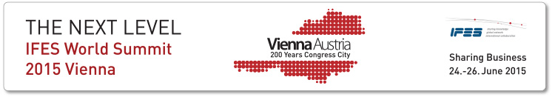

IFES WORLD SUMMIT 24 -26 June 2015
Side Events - Order form

Date | Activity | Price per person | Your order
24 June, 18:00 | IFES Press and Sponsors Welcome Cocktail & IMA Award Celebration | Invitation Only
25 June,  9:00-13:30 | City walk „Imperial Vienna“ incl. lunch  (Spouse programme) | € 90,-
25 June,  14:00-17:30 | Sightseeing tour „Classical Vienna“ incl. Schönbrunn Palace (Spouse programme) | € 80,-
25 June, 19:30 | Galadinner with Lord Mayor’s welcome  (Vienna City Hall) | € 140,-
26 June,  9:30-13:00 | Sightseeing tour „Art Nouveau“ incl. coffee at Demel’s (Spouse programme) | € 85,-
26 June,  10:00-13:00 | Cooking class „Viennese cuisine“ incl. lunch  (Spouse programme) | € 155,-
26 June,  14:00-18:00 | Sightseeing tour „Vienna Woods“  (Spouse programme) | € 85,-
26 June, 18:30 | Wine tasting | € 0,-
26 June, 19:00 | Dinner at a typical Viennese „Heuriger“ | € 105,-
27 June,  10:00-12:00 | City walk „Hidden Courtyards“ | € 35,-
27 June,  14:30-17:30 | Viennese Charm – incl. dancing lesson and coffee at Demel’s | € 95,-
27 June,  9:30-17:30 | Sightseeing tour „Danube Valley“ incl. boat trip | € 170,-
27 June, 19:00 | Gala performance Vienna Riding School | Cat.2 € 98,-  Cat.1 €140,- | Cat.2  Cat.1
27 June – 28 June | Salzburg | € 600,-
 |  | Total in EUR:
Your Company Name: _____________________________________________
Name of attendees: ________________________________________________________________
Your invoice address: ________________________________________________________________
Date and signature: ___________________ ___________________________________________

Tours offered in small groups. All guides are English speaking.
Registration deadline: 20 May 2015 for the tours, 31 May for dinners and Cooking Class
Please send Your Order Form via email to: info@ifesnet.org

